**Grep Assignment**

1. **Use any .c file. Using grep command extract and display** 
   1. **all lines beginning with #include with line numbers**

grep -n '^#include' example.c

* 1. **display all lines which do not begin with #include**

grep -v -n '^#include' example.c

* 1. **display the line number of main()**

grep -n 'main()' example.c

* 1. **extract all lines containing characters of opening and closing parathesis {(,))**

grep -n '[{}]' example.c

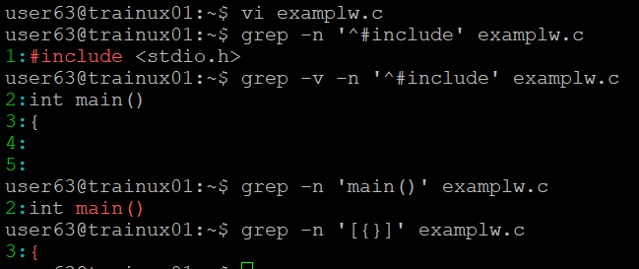

1. **Perform the above operations on a set of *.c files**
   1. **grep -n '^#include' *.c**
   2. **grep -v -n '^#include' *.c**
   3. **grep -n 'main()' *.c**
   4. **grep -n '[{}]' *.c**

